Step 1:

How to reset the Remote Desktop Server Licensing Grace Period on Windows Server 2012 R2 with Remote Desktop Services (not recommended)

while working in RDS, in one of my server was set up for RDS all in one and forgot to update the license key and it was on trial.  
while doing RDS I got below error.  
"Remote session was disconnected because there are no Remote Desktop client access licenses available for this computer. Please contact the server administrator"

[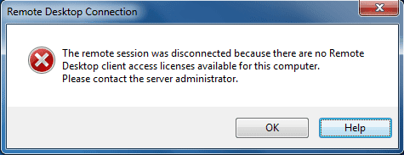](https://4.bp.blogspot.com/-bAxe9hu_raE/WAx-qP78yKI/AAAAAAAADj0/r3QAHPKpLdIBZ2mGpUkLEis20MAj5LrFgCLcB/s1600/0.png)

This clearly says about the license key.  
but when I was trying RDP to server, I got same error.  
trick is you should log in as admin.

Step 2:

Then open the regedit and go till **HKEY_LOCAL_MACHINE\SYSTEM\CurrentControlSet\Control\Terminal Server\RCM\GracePeriod** and delete the value (not the Default key).

[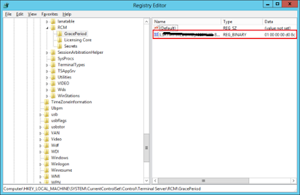](https://1.bp.blogspot.com/-394DXJ4UfOI/WAx_RroORoI/AAAAAAAADj4/uDB4Nb0u5goaMDLt0hnEbWW4wLQMr4H5ACLcB/s1600/regkey-650x424.png)

now restart your machine and you will get another 120 days free key.